Crewe Cemetery Lodge - Change of Use Alterations

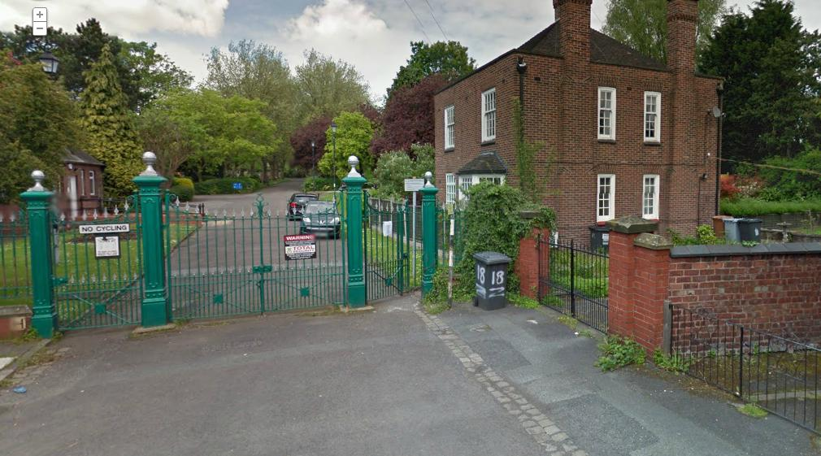

Invitation to provide a Mini Tender for Competition under the
Low Value Construction Services Framework

Lot 7 – Refurbishment Works

for the

Change of Use Alterations at Crewe Cemetery Lodge

Cheshire East Borough Council
REQUEST FOR PROPOSAL FOR
Change of Use Alterations at Crewe Cemetery Lodge

SUMMARY INSTRUCTIONS AND DETAILS OF CONTRACT
ITEM | CONTRACT DETAILS
Procuring Officer: | Robert Edwards, Asset Management Service
Submission instructions: | Submissions must be received via The Chest  https://www.thechest.nwce.gov.uk  Please note you are required to download the mini competition documentation and upload the completed mini tender submission by 12.00 Noon on Tuesday 2nd December 2014  1. Please ensure you leave sufficient time to upload your mini tender submission prior to the closing date/time.  2. The Council cannot be held responsible for technical/ICT issues in leaving the uploading of your submission too late. No submission received after this closing date and time will be considered other than where there are exceptional Circumstances, which may be considered by the Borough Solicitor in his/her sole discretion. Please note that submissions, which are partly through being uploaded at the closing time, will be considered to have not been received.  3. Where several documents are to be enclosed, preference would be for these to be 'zipped' as one file and attached to the portal. Please do not send any additional company literature/brochures if these have not been requested.  4. Mini tenders which have commenced being uploaded before the closing time but have not finished being uploaded by the closing time will be registered by the system as a late quote.  5. Mini tenders submitted by post, fax or other electronic means will not be accepted.
Date/time for mini tender return: | 12.00 Noon on Tuesday 2nd December 2014

Timetable
This timetable is indicative only. The Council reserves the right to change it at its discretion.

Stage | Date(s)/time
Issue of Mini Competition Documentation | Wednesday 12 November 2014
Clarification questions | By Thursday 20th November via Chest, responses by Monday 24th November
Deadline for Submission of Mini Tender | 12.00 Noon on Tuesday 2nd December 2014
Evaluation of Mini Tender | Thursday 4th December 2014
Notification of result of evaluation | Thursday 4th December 2014
Expected date of award of Contract | Friday 12th December 2014
Contract commencement | Wednesday 7th January 2015

IMPORTANT NOTICE

This Mini Competition is issued to those companies appointed as Framework Providers (“contractors”) to Cheshire East Borough Council (the “Council”) to provide Change of Use Alterations at Crewe Cemetery Lodge (the “Contract”), their professional advisers and other parties essential to preparing a mini tender for this Contract (the “Tender”) and for no other purpose.
The contents of this Mini Competition, and of any other documentation sent to you in respect of this tender process, are provided on the basis that they remain the property of the Council and must be treated as confidential. If you are unable or unwilling to comply with this requirement you are required to destroy this Mini Competition and all associated documents immediately and not to retain any electronic or paper copies.

No supplier will undertake any publicity activities with any part of the media in relation to the Contract or this Mini Competition process without the prior written agreement of the Council, including agreement on the format and content of any publicity.
This Mini Competition is made available in good faith. No warranty is given as to the accuracy or completeness of the information contained in it and any liability or any inaccuracy or incompleteness is therefore expressly disclaimed by the Council and its advisers.
The Council reserves the right to cancel the Mini Competition process at any point. The Council is not liable for any costs resulting from any cancellation of this process nor for any other costs incurred by those quoting for this Contract.

INSTRUCTIONS

- BACKGROUND

  - Further details of the Council’s requirements under the Contract and other relevant information are provided in the Project Brief and Service Specification.

  - If you have any questions or require any clarifications, please contact the Procuring Officer via The Chest [www.thechest.nwce.gov.uk].

  - Other than the person identified above, no Council employee or member of the Council has the authority to give any information or make any representation (express or implied) in relation to this Mini Competition or any other matter relating to the Contract.

  - Please note that the Council’s responses to any queries or clarification requests may, at the Council’s discretion, be circulated to all Tenderers.

  - The Council reserves the right to issue supplementary documentation at any time during the quotation process to clarify any issue or amend any aspect of the Mini Competition. All such further documentation that may be issued shall be deemed to form part of the Mini Competition and shall supplement and/or supersede any part of the Mini Competition to the extent indicated.

  - Suppliers must obtain for themselves at their own expense all information necessary for the preparation of their tender.

  - Under the Contract the Council will require compliance with its policies. Framework Providers are advised to satisfy themselves that they understand all of the requirements of the Contract before submitting their tender.

  - The Tender must be received in accordance with the relevant instructions no later than the time and date indicated.

  - Errors within the tender shall be dealt with in accordance with Alternative 2 contained in the JCT Practice Note – Tendering 2012.

- MINI COMPETITION SUBMISSION REQUIREMENTS

  - Submissions must be written in the English language.

  - Only one tender is permitted from each contractor. In the event that more than one is submitted by a contractor, the one with the latest time of submission will be evaluated and the other(s) disregarded.

  - The Tender (including price) should remain valid for a minimum period of 90 days.

  - The Tender must not be qualified in any way.

  - Any signatures must be made by a person who is authorised to commit the Tenderer to the Contract.

  - Your full registered business/name and main office address must also be provided on all documents.

  - The Council reserves the right to reject or disqualify a Tenderers submission where documents are completed incorrectly, are incomplete or fail to meet the Councils submission requirements which are detailed in this document.

  - The mini Tender submission must provide all of the information requested in the specified format and be completed in full and signed where indicated.

2.9 In the event that Tenderers believe that they are unable to submit a Tender through the electronic system or require assistance or further information to be able to use the e-tendering process they must contact the Procuring Officer no later than 4 calendar days before the submission date for the Tender to enable any technical queries to be investigated and resolved.

- CONTRACT DOCUMENTS

  - The conditions of contract will be JCT Minor Works 2011, completed in accordance with Appendix 3.

  - This Council is bound by procurement rules and cannot enter into any negotiations on the quotation or Contractual Terms and Conditions.

CONTENTS

Mini Tender Document

- Introduction
- Background
- Works Information
- Funding Approval
- Procurement of Framework Provider
- Submission and Evaluation
- Clarifications
- Documents to be Returned

Appendix 1 – Form of Tender
Appendix 2 – Commercial Submission
Appendix 3 – Contract Particulars / Contract Amendments
Appendix 4 – Works Information

- Introduction

This document is intended to give the Construction Providers in Lot 7 Refurbishment
Works, an opportunity to tender for the Change of Use Alterations at Crewe Cemetery Lodge

The tender will take the form of a mini competition between Providers. Your submissions should be based upon the information provided within this document.

- Background

The existing two-storey Lodge building owned by CEBC and is divided into two domestic apartments. Currently the Ground Floor apartment is occupied and leased by a tenant from Wulvern Housing Trust. The First floor apartment is currently unoccupied.
We propose to convert the first floor apartment into office accommodation for CEBC use. Planning Permission has been granted for the Change of Use. The works are to commence Wednesday 7 January 2015 with an anticipated six to eight weeks programme period

- Works Information
  - Scope of the Works
Change of Use Alterations at Crewe Cemetery Lodge

  - Works Information

Drawing Numbers 1806 – 01 / 02 / 03 / 04
Schedule of works
Pre-Construction information
Asbestos Refurbishment and Demolition Survey

- Funding Approval
Capital Maintenance Budget 2014 – 2015

- Procurement of Framework Provider

  - Procurement Process

Submission of a valid tender will result in the selection of a Contractor from the Framework panel to complete the task as outlined. The submission will be evaluated on the basis of Lowest Price.

- Submission and Evaluation

The submissions received will be judged on the basis of price only with the tenderer offering the lowest price being awarded the contract.

Tender Evaluation notes:-

    - The Council reserves the right not to award the contract at all.

    - Each tender will be checked initially for compliance with all requirements of the mini competition.

    - During the evaluation period, the Council reserves the right to seek clarification in writing or by means of a clarification meeting from any or all of the Providers to assist it in its consideration of their quotation.

    - Where the pricing of a Tender is abnormally low the Council reserves the right to reject the Tender in accordance with the requirements for further investigation under the Public Contracts Regulations 2006.

- Clarifications

To ensure transparency and fairness any inquires regarding the mini competition are to be submitted in writing through the CHEST portal, by the date shown in the timetable above.

When you first access the documents, please satisfy yourself that you have seen any clarifications which may have already been posted. Clarifications with the relevant responses will be posted on the CHEST for all applicants to view. It is in your interest to visit the clarifications regularly, as a response may fundamentally affect your submission. Questions raised outside of the clarification period may not be answered because responding to a clarification at this stage may not allow revisions to submissions so close to the deadline for the submission returns.

Any information that is dispensed in response to requests for clarification will be distributed to all applicants. If an applicant considers their enquiry to be specifically innovative to their offer, which should be clearly communicated within their correspondence, the team will decide whether the request for information is actually ‘innovative’ to the Applicant’s offer. If not considered to fall within that category the Applicant will be informed so they may make a decision as to whether to continue with this line of enquiry.

No employee except the designated Framework Manager leading this procurement has any authority to make any representation to Candidates as to the meaning of the mini competition or other such documentation. If clarification is required, please submit your inquiry via the CHEST. No approaches in connection with the work described must be made to any representatives other than formally through the Authorised Representatives detailed.

It is not anticipated to hold post tender interviews.

- Documents to be returned

Your response must be uploaded onto the CHEST Portal and include all the requested information in the following order:

- Covering letter summarising the content of your tender and duly signed for and on behalf of your organisation by the person responsible for the delivery of the services in question
- Form of Tender
- ‘Commercial’ submission.

Submissions must be uploaded into the CHEST portal of Cheshire East Council’s electronic tendering system by no later than 12.00 Noon on Tuesday 2nd December 2014

You will have open access to the CHEST portal until the above closing date should you wish to amend your submission.

PLEASE NOTE

The electronic system used for the return of tenders has an automatic cut off time of 12.00.

It is important you allow enough time for your submission to be received in the chest before the closing date and time as the chest will register it as late.

Submission’s which have commence being uploaded before the closing time but have not finished being uploaded by the closing time will be registered by the system as late.

Please allow sufficient time to upload your documents before the closing time.

If your submission is received late it may not be accepted.

Freedom of Information Act and Environmental Information Statement

  - The Council is subject to The Freedom of Information Act 2000 (“Act”) and The Environmental Information Regulations 2004 (“EIR”).

- As part of the Council’s obligations under the Act or EIR, it may be required to disclose information concerning the procurement process or the Contract to anyone who makes a reasonable request.

- If Tenderers consider that any of the information provided in their Tender is commercially sensitive (meaning it could reasonably cause prejudice to the Organisation if disclosed to a third party) then it should be clearly marked as "Not for disclosure to third parties” together with valid reasons in support Of the information being exempt from disclosure under the Act and the EIR.

- The Council will endeavour to consult with Tenderers and have regard to comments and any objections before it releases any information to a third party under the Act or the EIR. However the Council shall be entitled to determine in its absolute discretion whether any information is exempt from the Act and/or the EIR, or is to be disclosed in response to a request of information. The Council must make its decision on disclosure in accordance with the provisions of the Act or the EIR and can only withhold information if it is covered by an exemption from disclosure under the Act or the EIR.

- The Council will not be held liable for any loss or prejudice caused by the disclosure of information that:

    - has not been clearly marked as "Not for disclosure to third parties" with supporting reasons (referring to the relevant category of exemption under the Act or EIR where possible); or

    - does not fall into a category of information that is exempt from disclosure under the Act or EIR (for example, a trade secret or would be likely to prejudice the commercial interests of any person); or

    - in cases where there is no absolute statutory duty to withhold information, then notwithstanding the previous clauses, in circumstances where it is in the public interest to disclose any such information.

